Lab 2 - Graphical Analysis of Free Fall - Fall 2022

# Overview

Visualizing data is crucial in order to understand how a physical process works. In the lab you will use graphs to determine how fast an object, like a golf ball, falls when it is close to the Earth’s surface.

# Part 1 - Bouncing Ball

One of the first classic experiments in physics is measuring the rate of the falling object. When an object moves and the only force acting on the object is gravity, the object is said to be in [*free fall*](https://openstax.org/books/university-physics-volume-1/pages/3-5-free-fall). In this lab you will measure a golf ball as it bounces up and down on the floor. During the moments of time when the ball is *not* in contact with the floor we say the ball is in free fall.

The first thing you will do is bounce a golf ball on the floor near the lab table you are sitting at. Start by holding the ball approximately 30 cm (1 foot) above the floor. Release the ball and allow it to bounce 5 or 6 times. **The ball should stay in the same spot on the floor it bounces.** If the ball tends to dribble away, move to a different spot.

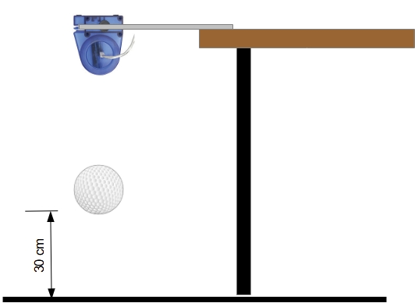

Now place the motion sensor over the spot of floor you chose to bounce the ball. We will be using the software Capstone to monitor the motion of the ball. There is a file “Free Fall - Student Data.cap” on Moodle you should download and launch on the lab laptop.

* Drop the ball and click the “Record” button in the lower left corner of the Capstone app.
* Record about 5 or 6 bounces of the ball then click Stop. **CAUTION: the motion sensor uses echolocation to measure the position of the ball, so anything in the field of view (hand or foot) of the sensor can be detected. So make sure your hand or foot is not in the way.**
* Click the Fit to Scale icon Scale to Fit on the toolbar at the top of the graph to make the graphs full scale.

Your data should look something like this:

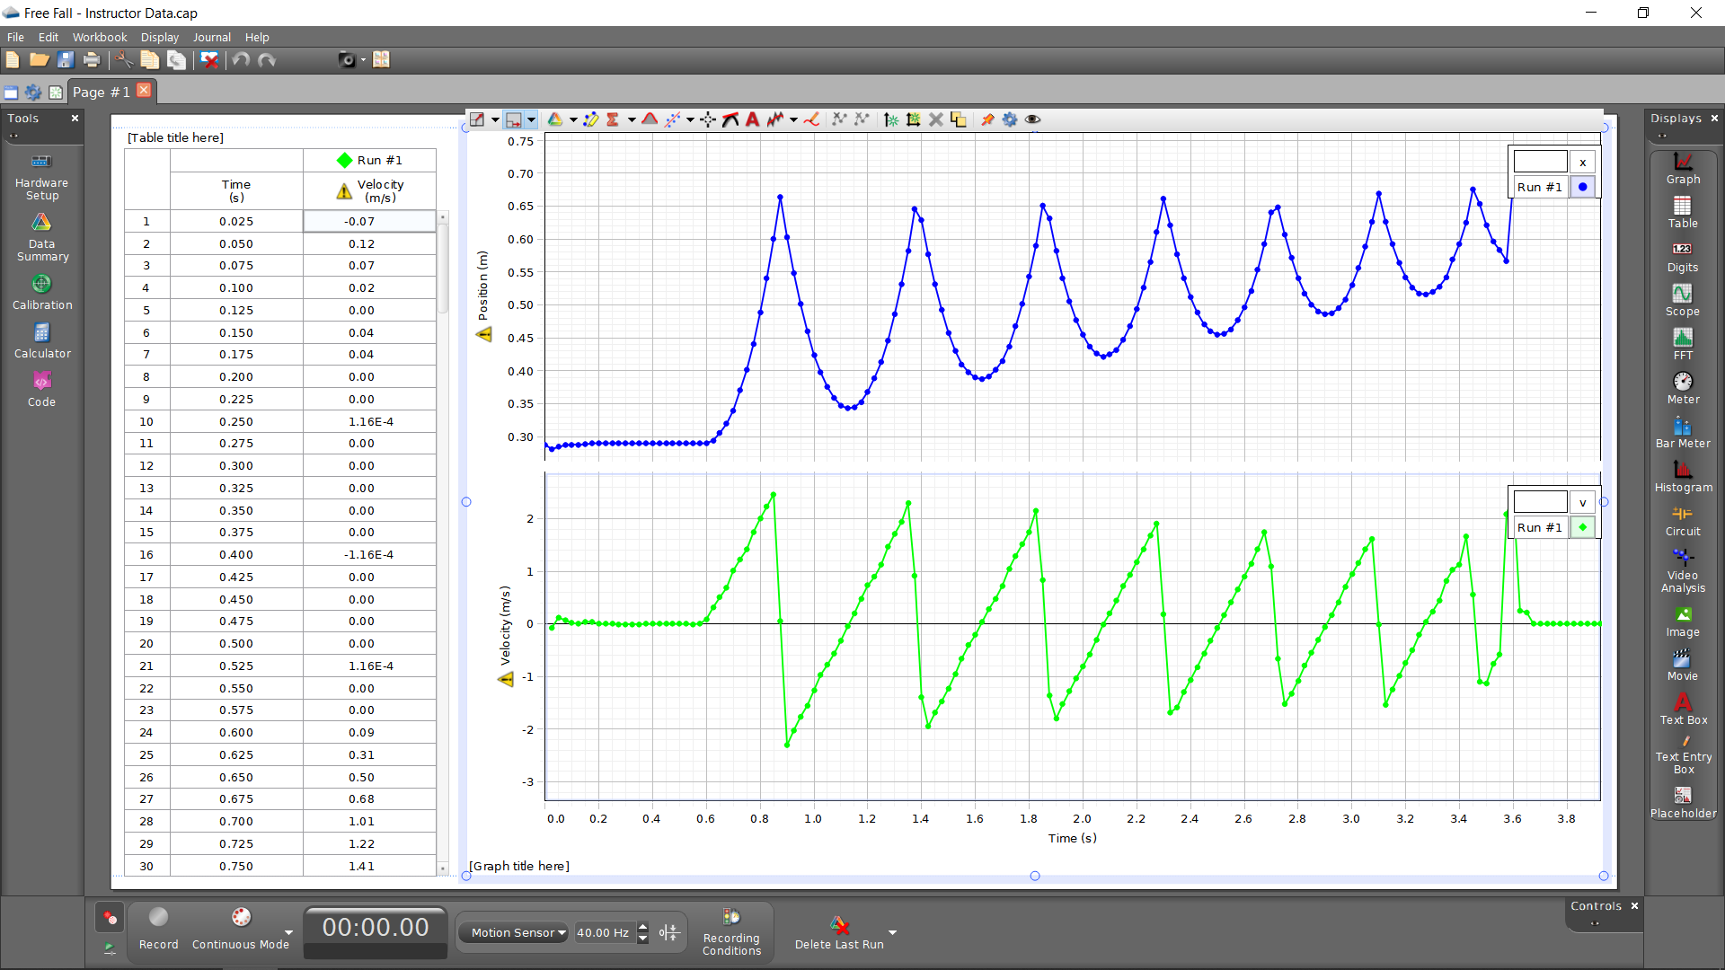

The upper graph is a plot of position vs. time and the lower graph is a plot of velocity vs. time.

1. Press Print Screen (PrtScr) on the laptop keyboard and insert a screenshot of the Capstone app with *your* data here:

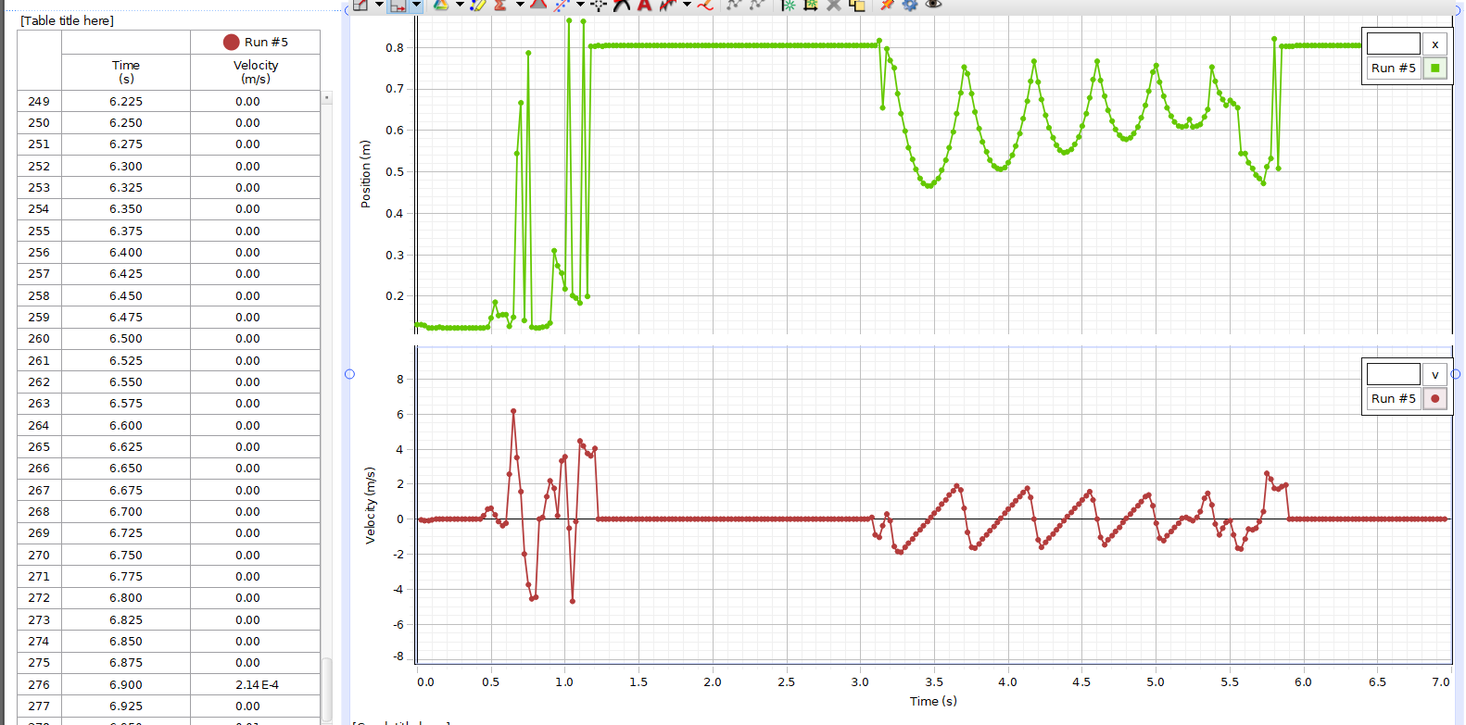

1. Look at *your* plot of position vs. time. Based on the plot, is the golf ball accelerating? Explain why.

The golf ball is accelerating towards the ground due to gravity based on the plot it is slowing down with a negative acceleration.

1. Position, velocity and acceleration are all *vectors*. Vectors have both a magnitude and direction. If we say up from the floor is positive, is the acceleration of the golf ball positive or negative? Explain why.

The acceleration is both negative and positive, when it is falling it is negatively accelerating due to gravity then for a short moment it bounces off the ground and accelerates upwards, then it immediately starts accelerating downwards again.

1. Look at *your* plot of velocity vs. time. Based on the golf ball accelerating constantly or changing with time? Explain why.

The ball’s velocity is changing the whole time, for a moment it has high positive acceleration and then for a longer period of time it is accelerating negatively

1. Are there moments when the ball is in free fall and not moving? Is the golf ball still accelerating? Explain why.

There are moments that the ball is not moving, but it still has acceleration since gravity constantly accelerates the object downward.

The description of the motion of an object in terms of its [position, velocity](https://openstax.org/books/university-physics-volume-1/pages/3-1-position-displacement-and-average-velocity), and acceleration is called [*kinematics*](https://openstax.org/books/university-physics-volume-1/pages/3-introduction). From two graphs you can actually say a lot about how an object is moving. Now we want to quantify some of these kinematic values; especially the acceleration of the ball in free fall. Long ago it was observed that objects fall at constant acceleration when close to the Earth’s surface. Even more interesting, the value of the acceleration did not seem to depend on the object’s mass. So the *model* we will use to determine the acceleration due to gravity is that the gravitational acceleration (or free fall acceleration) is [*constant acceleration*](https://openstax.org/books/university-physics-volume-1/pages/3-4-motion-with-constant-acceleration).

Let’s now measure the acceleration of the ball in free fall. There are several icons on the top of the graph of position vs. time. These icons are tools you can use to adjust and analyze the graphs. If you move the mouse arrow over an icon, a pop up text box will appear with a description of the tool.

* Click in the space for the velocity vs. time to select this graph.
* Click the Data Highlighter button Highlighter on the toolbar. A highlighter box will appear in the graph of velocity vs. time. Move and resize the highlighter box so it fits over a line segment in the graph. **Make sure you do NOT select points at the moments the ball hits the floor**.
* Click the Curve Fits button Curve Fit Tool on the graph toolbar to activate the curve fitting function. Next to the Curve Fits button is a small drop menu arrow. Open the drop menu and select the fit Linear: mt + b.

1. In the line segment of the velocity vs. time graph, what part of the line segment (slope or intercept) represents acceleration? Explain why.

The part of the line segment that represents acceleration is the slope of the velocity graph, this is because the derivative of velocity is acceleration. Derivative represents the slope of a graph.

When you activated the Curve Fits tool, A box popped up with the values of the best fit slope and intercept of the fitted line.

1. Record the values of the slope and intercept and their respective errors in the table below. Include the error and *units* of the values.

| Slope | Intercept |
| --- | --- |
| 10 +/- .042 | -34.7 +/- .15 |

When you did a linear fit to the selected data, a line appeared over the selected data. The slope and intercept of that line are given from the fit. But why is *that* line the best line for the selected data? How does the application determine what line best fits the data? We are going to analyze the data again in a spreadsheet to understand how the line of best fit is determined.

* Open the spreadsheet “Free Fall - Student Data.” Click the menu File >Make a copy to make a copy for yourself.
* To the left of the graphs is a table of data. Notice that the values of velocity are highlighted. These are the same values of velocity that are highlighted in the box in the graph.
* With the mouse point click and drag across the values of time AND velocity in the table that are highlighted.
* Make a copy of the selected data by clicking the menu Edit > Copy or by clicking the keyboard Crtl+C.
* In the spreadsheet “Free Fall - Student Copy'', click in the cell A1, then click the menu Edit > Paste or click the keyboard Crtl+V.

You should now have a copy of the data from Capstone of the free falling ball.

1. Make a graph of velocity vs time
   1. Click in cell A1 and drag the mouse point across the values of time and velocity.
   2. Click the menu Insert > Chart.
   3. In the Chart editor > Setup make sure the Chart type is Scatter chart.
   4. Data range > X-axis is Time (Column A).
   5. Data range > Series is Velocity (Column B).
   6. Click Chart editor > Customize > Series and check Trendline
   7. Click the Label menu and select Use Equation
   8. Copy and paste your graph here:

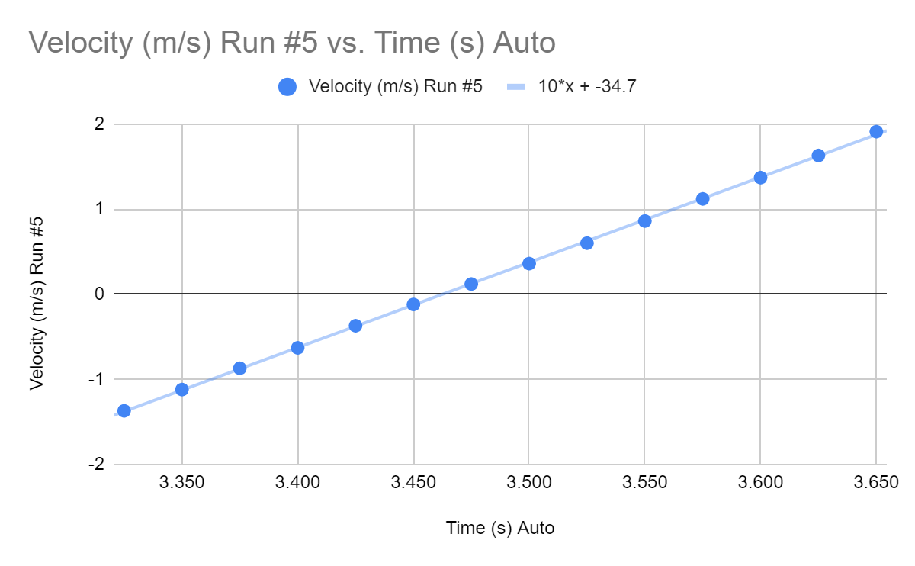

You should now have a best fit line over the data in your graph. There is also an equation in the graph with the best fit slope and intercept. But why are these values of slope and intercept the “best” value? How does the spreadsheet know what is the best fit?

# Part 2 - LINEST(): Linear Fit Routine

In programs like Capstone or Google Sheets or Microsoft Excel there are built in routines that can fit trendlines to data. Many data analysis software have routines that can determine a line of best fit to a set of data. Most of these fitting routines use a technique of minimization to determine what parameters of a line (the slope and intercept) best fit the data. We will use the technique of Least Squares to find the line of best fit. To do this we have to define a quantity called the Residual. The residual is the difference between the measured y-value and the y-value of the best fit line.

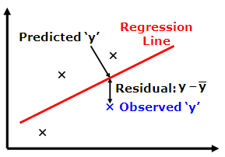

The smaller the residual, the closer the best fit line is to the data. Each datum has a residual and the residual can be either positive or negative depending if the best line is higher or lower than the datum. Changing the line to reduce the residual for one point can in turn make the residual for another point bigger. We want to find the best fit line that *minimizes* the residuals for ALL of the points. The quantity we want to minimize is called the [Sum Squared Residuals](https://en.wikipedia.org/wiki/Residual_sum_of_squares).

Fortunately there are routines built into programs that can do the calculation for us. One useful routine is LINEST(). When you use LINEST() in a spreadsheet, start with an equal sign “=”. LINEST has four arguments:

* The values of your y data.
* The values of your x data.
* 1 or 0 to calculate the y-intercept.
* 1 or 0 to return all of the statistics.

LINEST() returns a table of statistics:

| Slope | Intercept |
| --- | --- |
| Error of Slope | Error of Intercept |
| Correlation Coefficient R2 | Standard Error |
| F Statistics | Degrees of Freedom |
| Sum of Square Regression | Sum Squared Residuals |

1. Use the built in routine LINEST to determine the best slope and intercept of velocity vs. time.
   1. In an empty cell G2 enter =LINEST(range of y,range of x,1,1).
   2. The range of y should be the range of cells with velocity in Column B.
   3. The range of x should be the range of cells with time in Column A.
2. Tabulate the values of the best slope and intercept from Capstone, the Google Sheet trendline of velocity vs. time, and LINEST(). Include the error and *units* of the values. NOTE: the trendline does NOT tell you the errors of slope and intercept.

|  | Slope | Intercept |
| --- | --- | --- |
| Capstone | 10 +/- .042 | -34.7+/-0.15 |
| Trendline | 10 | -34.7 |
| LINEST() | 10.00879121 +/- 0.0385211469 | -34.6563736263736 +/- 0.1343985785 |

# Part 3 - Mystery Planet

Now imagine you are traveling to another planet in our solar system. On your journey you bring a golf ball and a motion sensor. You land on a planet, but you are not sure which planet it is, but you can figure out which planet it is by measuring the gravitational acceleration of the fall golf ball.

Your lab TA will assign you a set of data from one of the Mystery Planets:

* Go to the assignment for Free Fall lab on the Lab Moodle and open the spreadsheet of the mystery planet assigned to you.
* Click the menu File > Make a copy of the spreadsheet so you can make edits.
* On the tab labeled “Fit by Hand” is the data of time and velocity of a free fall object on the mystery planet.
* The graph of velocity vs. time plots two different velocities: blue dots for the data and a red line for the best fit velocity.
* In the orange shaded boxes are the values of the slope and intercept for the best velocity line.
* In the blue shaded box is the Sum Squared Residuals (SSRESID).

Your challenge is to fit the red best fit line to the blue data dots. In the orange boxes you must enter your initial guess of the best fit slope and intercept for the red line. You will have to repeat guesses, each time moving the line to better fit the data. With each guess the SSRESID will go down. Continue until you have minimized the SSRESID as much as you can.

1. Record your final values of slope and intercept that you feel best fit the data in the table below. Include your estimate of error and *units* of the values:

| Slope | Intercept |
| --- | --- |
| 1.667 +/- .05 | -.822 +/- .05 |

1. Record your smallest Sum Squared Residuals (SSRESID) in the table below:

| SSRESID |
| --- |
| **0.0313909** |

Now you have a value of the gravitational acceleration of the planet you are on, you compare your result with a table of accelerations on different planets in the solar system:

| Planet | Gravitational Acceleration (m/s^2) |
| --- | --- |
| Moon (yes, the moon is not a planet) | 1.62 |
| Mercury | 3.59 |
| Venus | 8.87 |
| Mars | 3.77 |
| Jupiter | 25.95 |
| Saturn | 11.08 |
| Uranus | 10.67 |
| Neptune | 14.07 |

1. Based on the table above and your fit by hand, what planet have you landed on?

The moon

Finally, let’s analyze the data using LINEST:

* Copy the data of time and velocity from the tab “Fit by Hand” to “Fit by LINEST.”

1. Record the values of the slope and intercept and their respective errors in the table below. Include the error and *units* of the values.

| Slope | Intercept |
| --- | --- |
| 1.624804511 +/- 0.01064543857 | -0.7992142857+/-0.01183033484 |